COS80023 Big Data – Lab 9
Lab 9: Pass Task 9 – Natural Language Processing
Student Name: Arun Ragavendhar Arunachalam Palaniyappan
Student ID: 104837257

Exercise 1
Q1. What do these numbers tell you? Why did we give table() the argument data.raw$type?
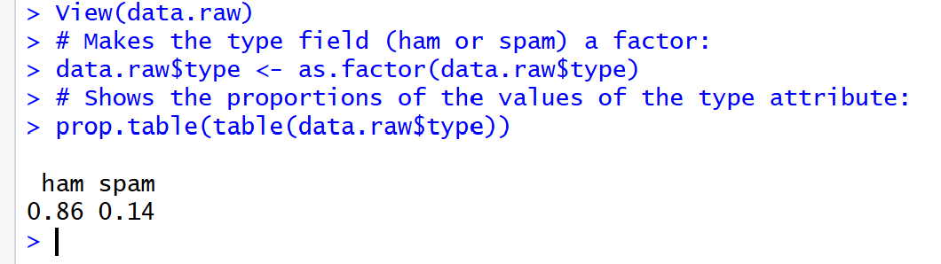
The command table(data.raw$type) counts how many SMS messages are labelled ham and how many are spam.
prop.table() then converts these counts into proportions.
These numbers show that most messages in the dataset are ham (86%) while only a smaller share is spam (14%). We gave table() function, the argument data.raw$type, because that column holds the message type label (ham or spam). Looking at these proportions tells us the dataset is imbalanced, with far more legitimate messages than spam, which is typical in real SMS collections.

Exercise 2
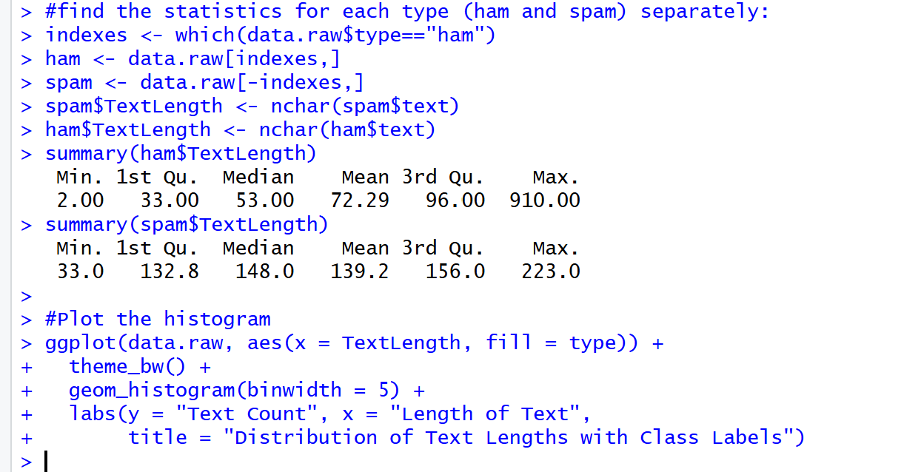
Q2. What does this code do, and what does the output tell us about ham and spam?
The code separates the data into ham and spam groups, measures the number of characters in each message using nchar(), and then plots a histogram of message lengths.
From the plot and summary values we can see that ham messages are generally shorter and more consistent, while spam messages are usually longer and vary more in length because they contain promotions, URLs, or phone numbers.
This difference in message length is an early indicator that text-length features can help distinguish spam from ham.

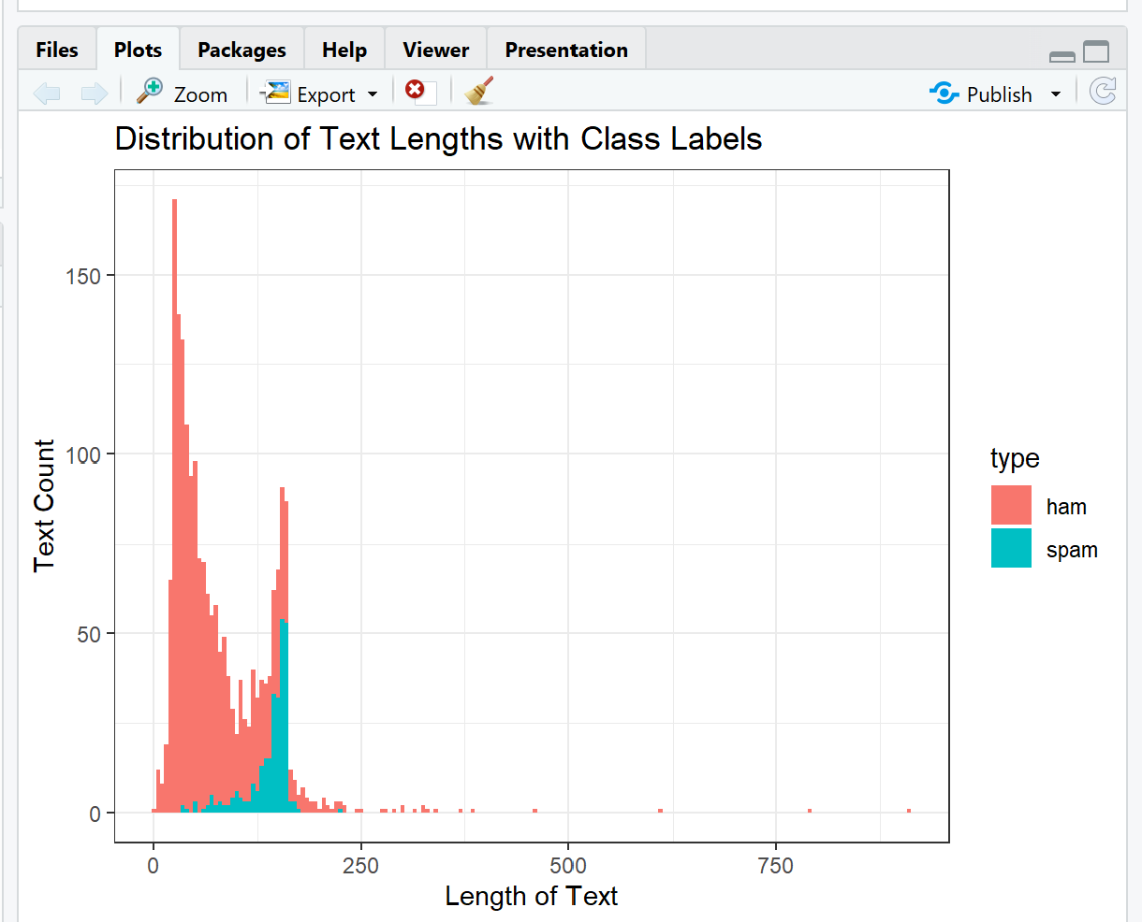
In this histogram, the Length of Text axis measures how many characters each message contains, while the Text Count axis shows how many messages fall into each length range.

Exercise 3
Q3. Which NLP processing steps are performed by this code? Is the outcome what you expect?
The code performs the main text-pre-processing steps used in Natural Language Processing:
- Tokenisation – splits each message into individual words.
- Lower-casing – makes all words lower case so “Buy” and “buy” are treated the same.
- Stop-word removal – removes very common words such as the, and, is that add little meaning.
- Stemming – reduces words to their root form (e.g., offers, offering → offer).
After these steps, the total number of unique tokens becomes smaller and the text cleaner and more uniform.
Yes, this is exactly the expected outcome before creating the document-frequency matrix for modelling.

The DFM was created
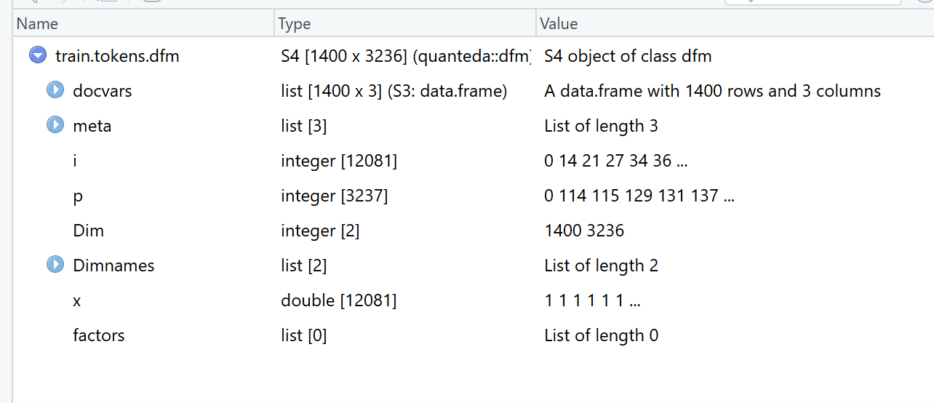

Q4. How do you create 3-grams? How does data.tokens change?
We can create 3-grams (sequences of three consecutive words) by setting the ngrams option in the tokens () function:
train.tokens <- tokens (train.raw$text, what = "word", remove_numbers = TRUE, remove_punct = TRUE, remove_symbols = TRUE, remove_hyphens = TRUE, ngrams = 3)
After this change, each token becomes a phrase of three words instead of one.
data.tokens therefore grows in both size and vocabulary because many more unique word combinations are recorded.
3-grams capture short expressions and word-order patterns that may improve classification.

Exercise 4
Q5. What has cbind changed in the data?
cbind(type = train.raw$type, data.tokens.df) adds the class label column (ham or spam) to the table of token features.
Before cbind, the dataset only contained the input variables (word-frequency counts).
After cbind, every row now has both its features and its correct output label.
This combined table is what the machine-learning algorithm uses for training.
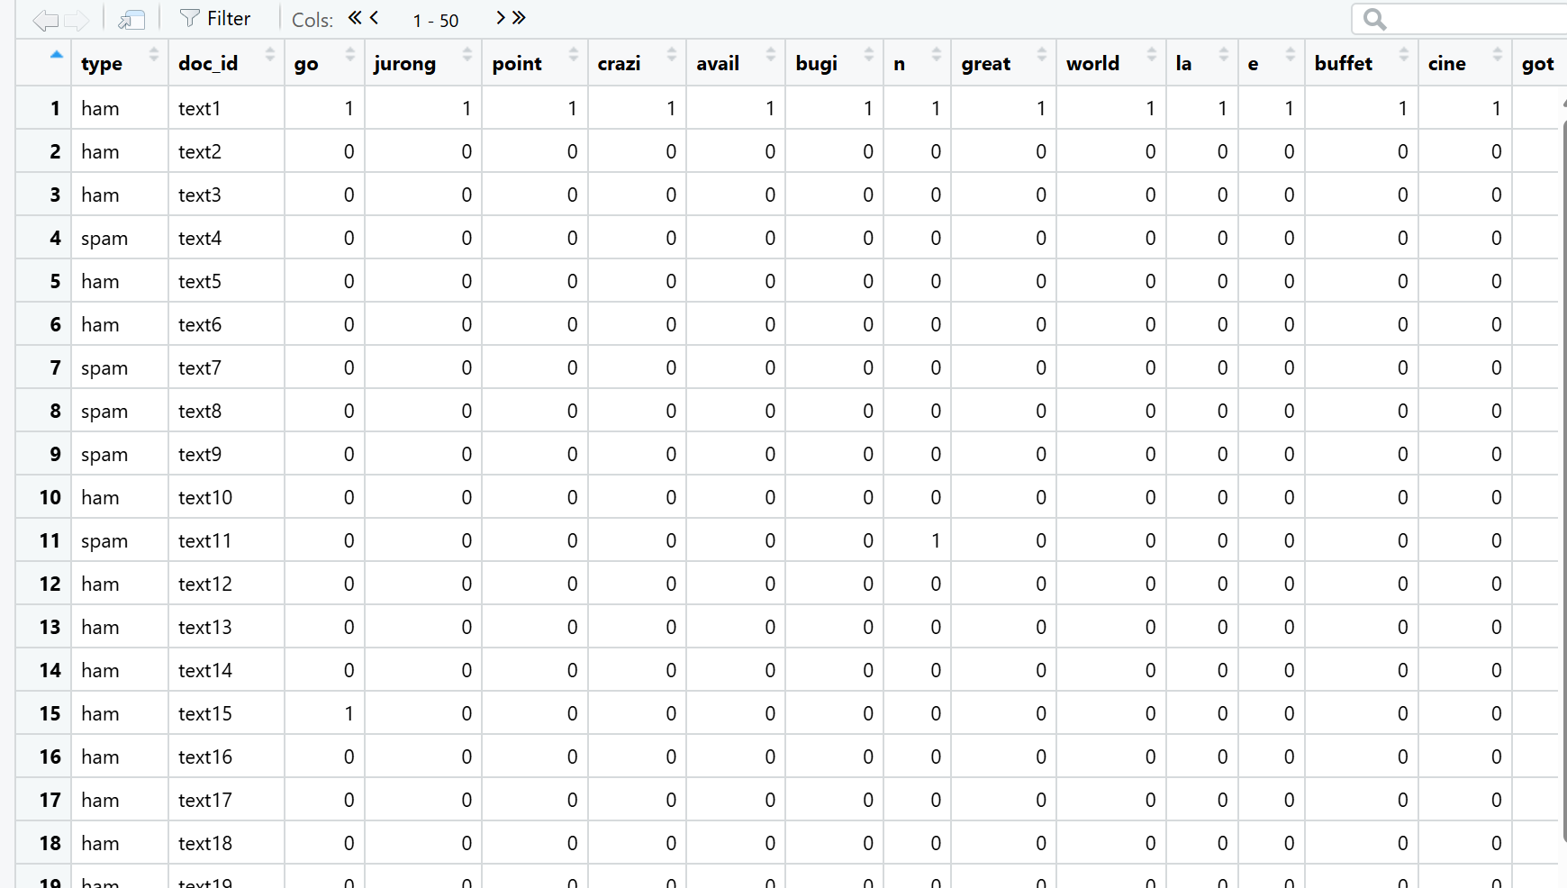
Q6. Why do we need to align the test set columns to the training set columns?
When we build the document-frequency matrix (DFM) for the test set, it may contain different tokens than the training set.
If we try to predict using mismatched columns, the model will not understand the extra or missing words.
By running
dfm_select(test.tokens.dfm, pattern = train.tokens.dfm, selection = "keep")
we keep only the token columns that also exist in the training data, so both data frames have exactly the same structure.
This alignment ensures the model reads each column as the same word or 3-gram in both training and testing phases.

Q7. How does the model perform on the training and testing sets (accuracy, specificity, sensitivity)?
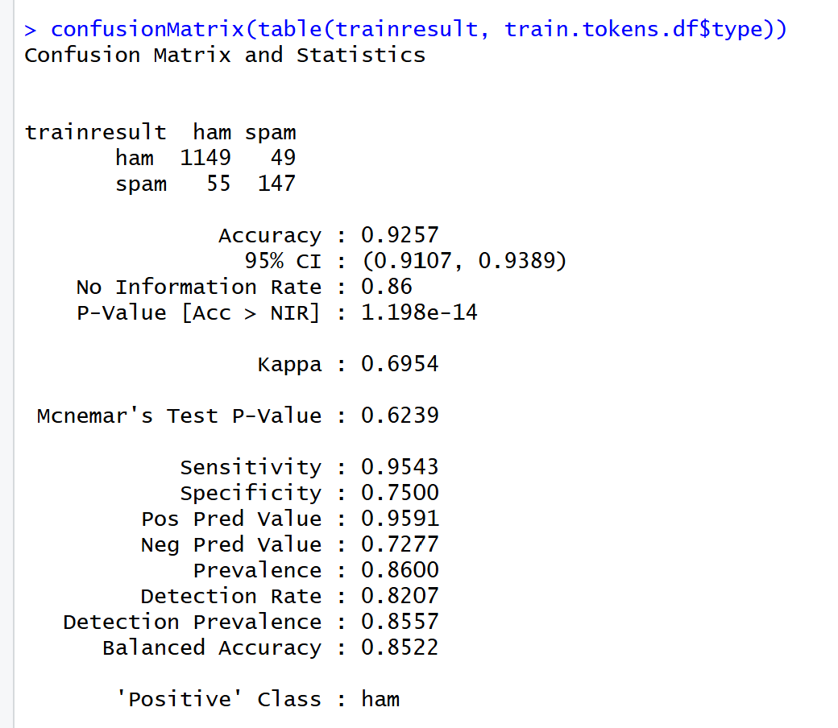
Model performance on training data

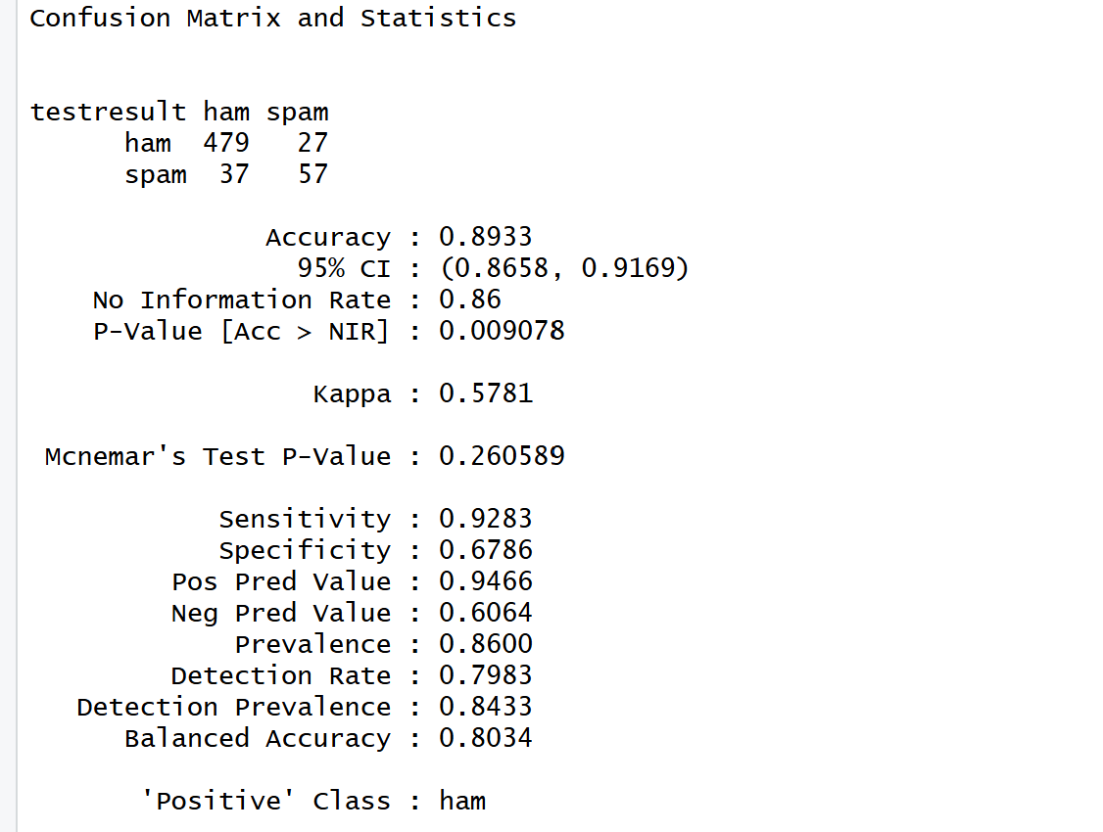\
Model Performance on testing data
The model performs well overall, showing slightly better results on the training data than on the testing data.
On the training set, it achieved an accuracy of 92.6%, with sensitivity = 0.954 and specificity = 0.750. This means it correctly identified most ham messages and recognised many spam messages. The Kappa value of 0.695 indicates good agreement between predicted and actual classes.
On the testing set, the accuracy was 89.3%, with sensitivity = 0.928 and specificity = 0.679. These values are slightly lower, as expected for unseen data, and the Kappa value of 0.578 still shows moderate to good agreement.
The difference between training and testing results is small, showing that the model is not overfitted and can generalise well to unseen data. Also, the confusion matrix shows that while the model is very good at identifying ham messages, it sometimes misses a noticeable number of spam messages. This means it is reliable for classifying normal messages correctly, but could be improved further to catch more spam, perhaps by adjusting the threshold or using techniques to handle the class imbalance.

